**Laboratory Three**



**Javier Jesús Macossay-Hernández**

**EE348L – Electronic Circuits**

**University of Southern California**

**Professor Susan Schober**

**Introduction**

In this laboratory, implementation of hand analysis and HSPICE simulations were done to understand the behavior of operational amplifiers and its application into filters for high and low frequencies. Furthermore, the circuits were built in class and different tests were done to them to corroborate our hand calculations and simulation results.

Exercise 1

**Procedure**

On Exercise 1, a comparator was built with a sinusoidal input with a frequency of 1 kHz and amplitude of 2.5 V.

**Data**

5 V on the Output

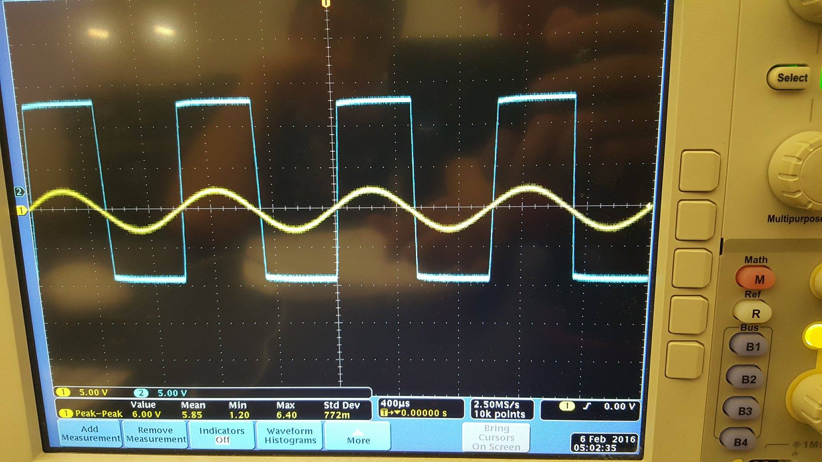

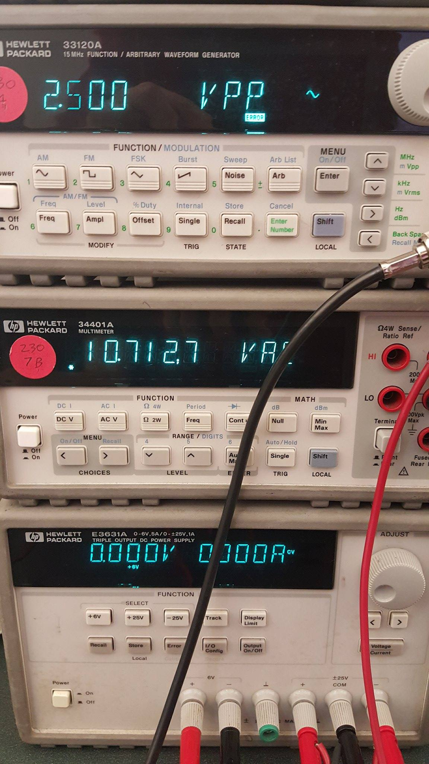

0 V on the Output

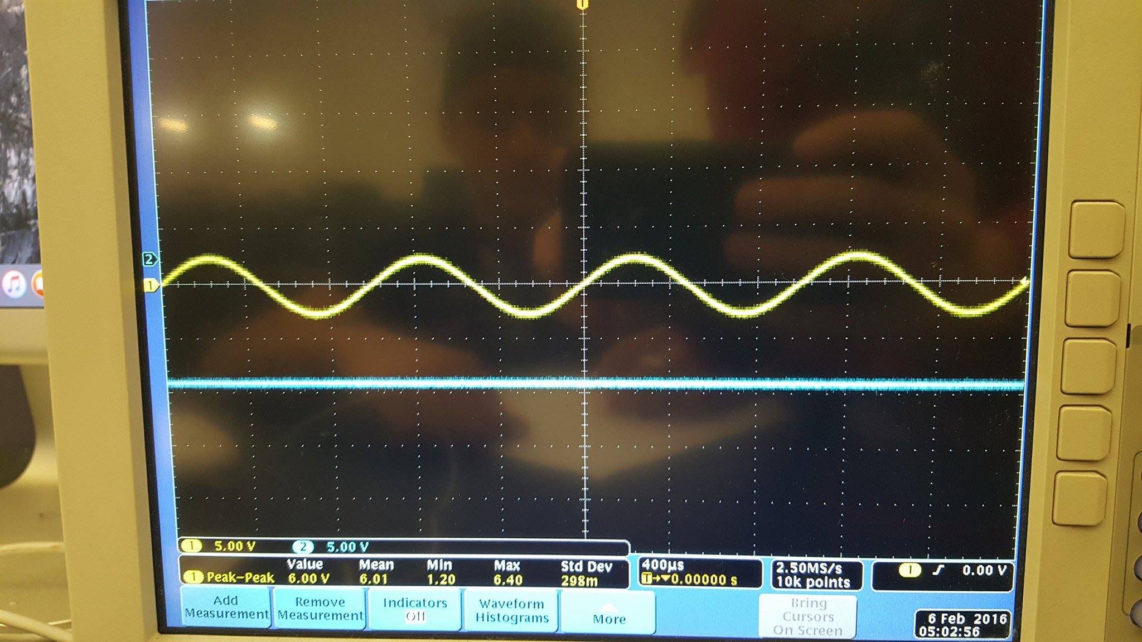

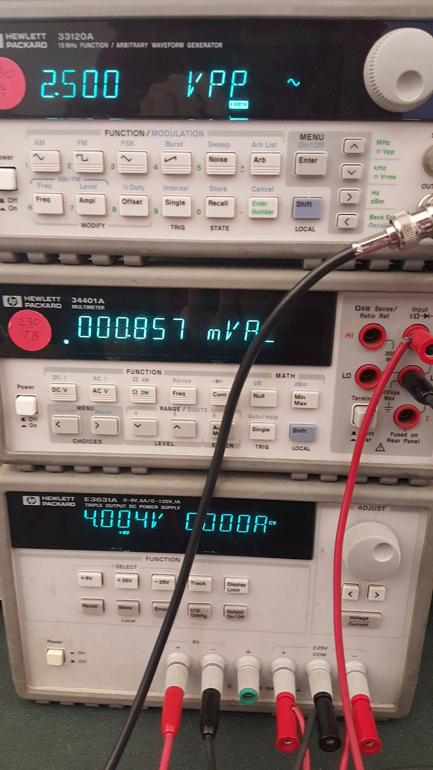

**Questions**

The output voltage is a square wave. As the voltage gets adjusted at the negative terminal, 4 V in our experiment, it gets to a point where the input voltage of 2.5 V is smaller the the negative terminal and the output is just a flat line. The flat line on the output voltage means that the output will always be low, in this case 0 V because it is connected to ground.

**Discussion**

The square wave output is due to the fact that the sine wave is varying from negative to positive values. Therefore, the output becomes low, 0 V, or high, 5 V. When the negative terminal voltage is larger than the positive terminal voltage, the output becomes low, which is 0 V. As a result, we get a flat line.

Exercise 2

**Procedure**

On Exercise 2, two amplifiers were built from the pre-laboratory section. The first one was a non-inverting amplifier and the second one an inverting amplifiers. Both of them had negative feedback.

**Data**

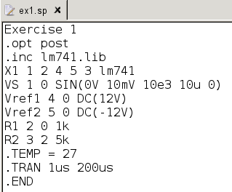

Non-Inverting Amplifier Netlist

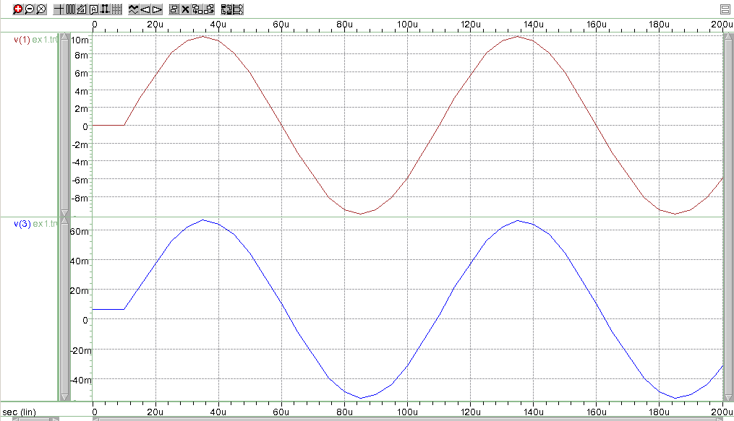

Non-Inverting Amplifier: Voltage Input and Voltage Output Ungrouped Graphs

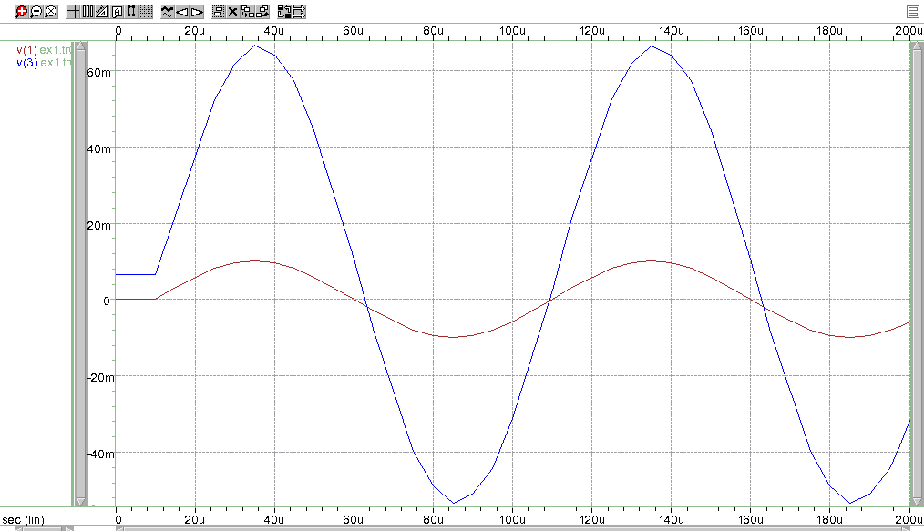

Non-Inverting Amplifier: Voltage Input and Voltage Output Grouped Graphs

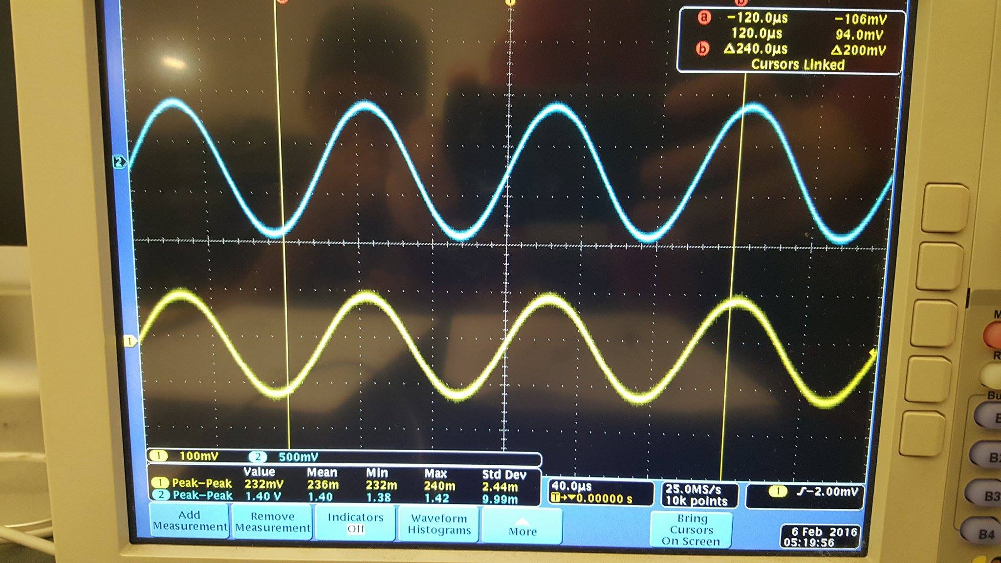

Non-Inverting Amplifier: Voltage Input and Voltage Output Laboratory Result

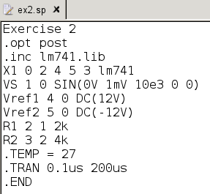

Inverting Amplifier Netlist

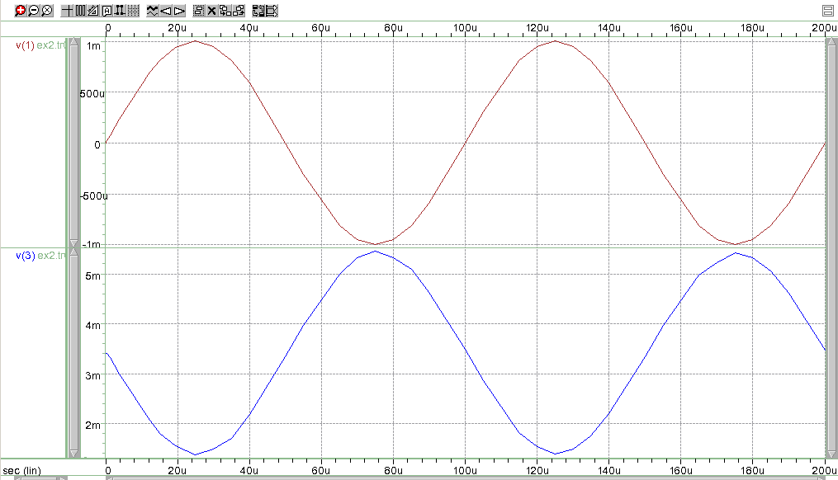

Inverting Amplifier: Voltage Input and Voltage Output Ungrouped Graphs

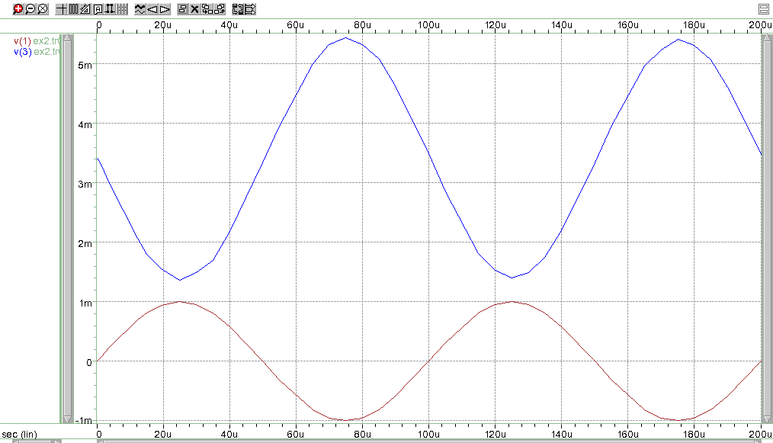

Inverting Amplifier: Voltage Input and Voltage Output Grouped Graphs

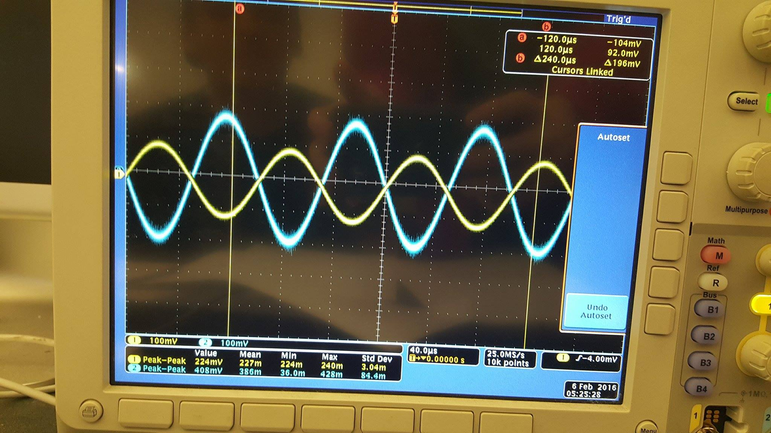

Inverting Amplifier: Voltage Input and Voltage Output Laboratory Result

**Questions**

For the non-inverting amplifier with negative feedback, the output of the hand calculations, HSPICE simulation, and the actual circuit matched. The resulting gain was equal to 6. In addition, the second-order phenomena that is occurring from section 3.5 in the non-inverting amplifier with negative feedback is offset voltage on the output.

For the inverting amplifier with negative feedback, the output of the hand calculations, HSPICE simulation, and the actual circuit matched. The resulting gain was equal to -2 (The negative sign it is due because it is an inverting amplifier. Therefore, the signal is inverted.). In addition, the second-order phenomena that is occurring from section 3.5 is the offset voltage on the output.

**Discussion**

The output signal was amplified according to the factor of the gain, corroborating hand calculations and HSPICE simulations. In addition, offset voltage phenomena was observed on the output.

Exercise 3

**Procedure.**

On Exercise 3, a buffer was built. Having as a result a unity gain, which is that the output voltage is equal to the input voltage.

**Data**

Unity Gain

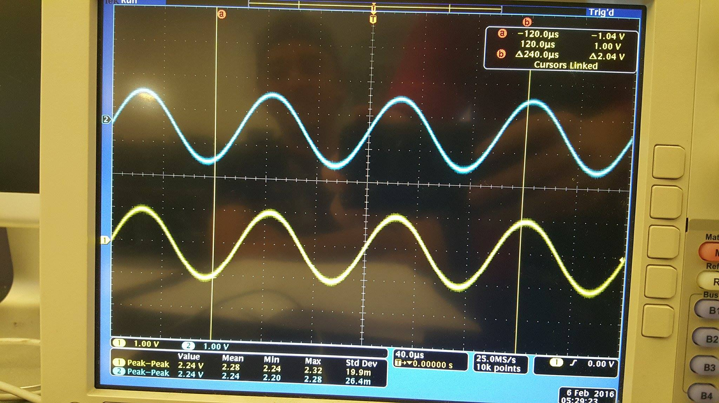

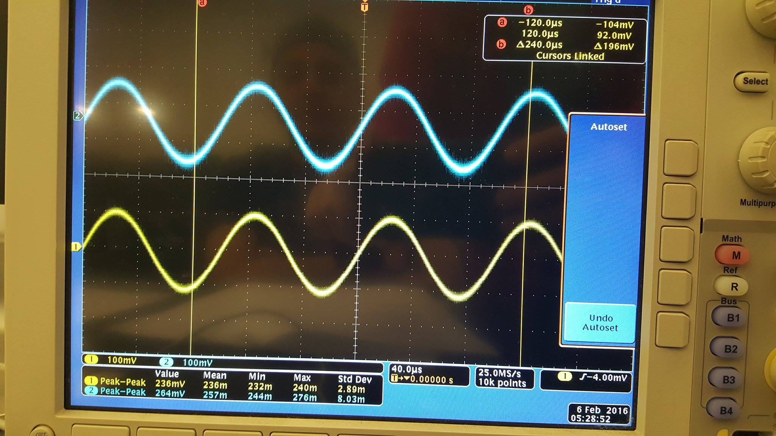

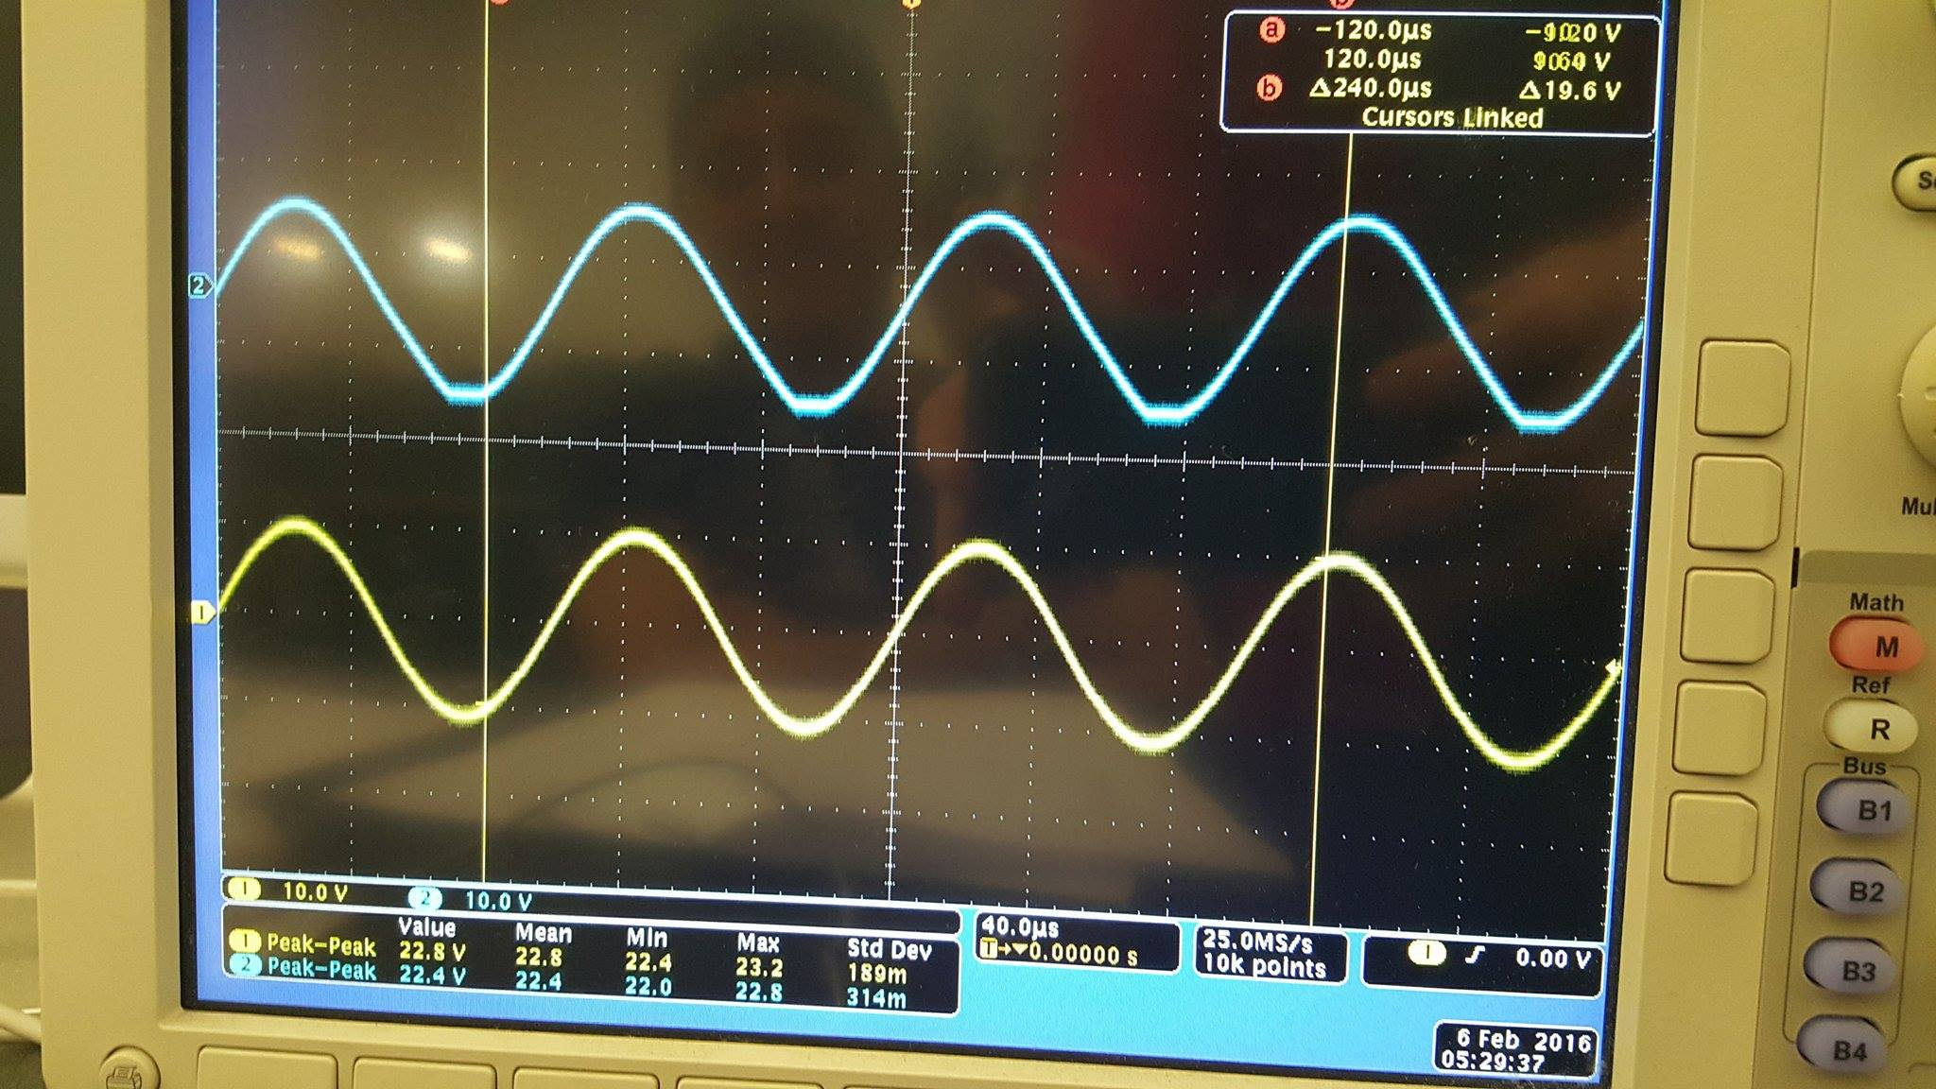

**Questions**

The buffer made in class matches perfectly to the hand analysis done in the pre-laboratory. The data gathered showed a unity gain.

**Discussion**

The data, showed in the Data section, matches with the hand calculations, which state that the voltage in the output should be the same as the voltage in the input.

Exercise 4

**Procedure**

On Exercise 4, a first order low-pass filter was made and, as expected, when the circuit was built only low frequencies passed through the filter.

**Data**

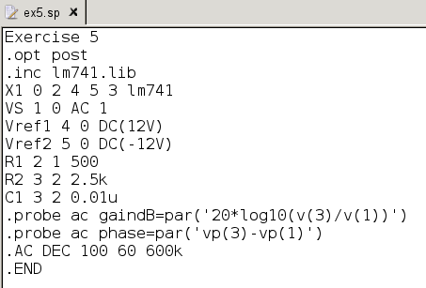

First Order Low-Pass Filter Netlist

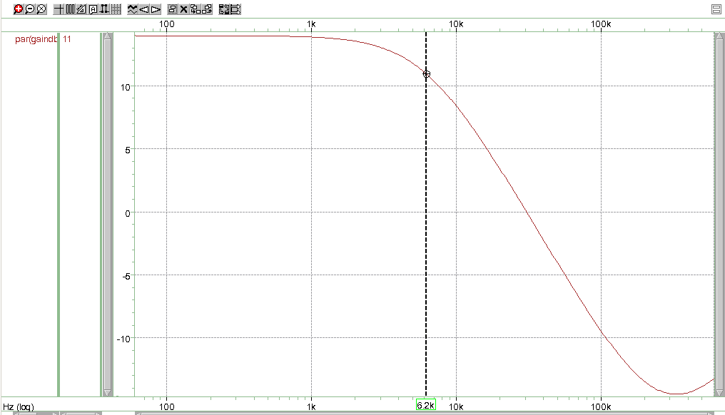

SPICE Simulation of First Order Low-Pass Filter Gain (dB) versus Frequency (Hz)

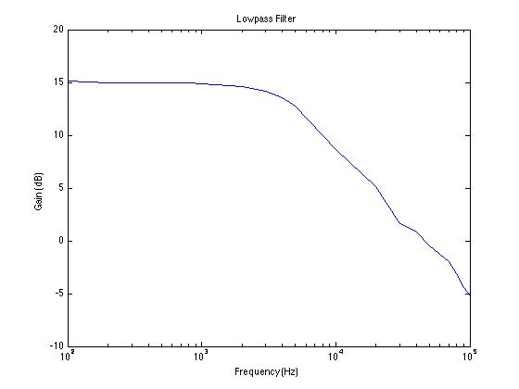

Measured Values of First Order Low-Pass Filter Gain (dB) versus Frequency (Hz)

**Questions**

The pass band gain is 5 and the -3 dB frequency is 5,787 Hz in the circuit. The -3 dB frequency is slightly different than the theoretical value from the hand calculations because the value used for the capacitor was 11 nF instead of 10 nF, but the resistor values remained the same. As expected, the results derived in the pre-laboratory section agree with the results from the laboratory. The measured values compare to the calculated results by giving similar numbers, 5.7 kHz (measured value) and 6.2 kHz (SPICE simulation value), and similar plots of the response of the circuit with the change in frequency were obtained. In addition, the SPICE simulation had 14 dB gain when frequency was equal to zero, but in the case of the measured values the gain is equal to 15 dB.

**Discussion**

The results form the HSpice simulation match with the hand calculations. Therefore, the hand calculations were done correctly. Some of the subtle differences in the results are due to the fact that the LM741 used is not ideal, as opposed to the one used in the SPICE simulation. This is due to the fabrication process of the LM741 where we could possible find impurities or holes in the materials used to produce it.

Exercise 5

**Procedure**

On Exercise 5, a first order high-pass filter was made from configuration in Figure 3-21.

**Data**

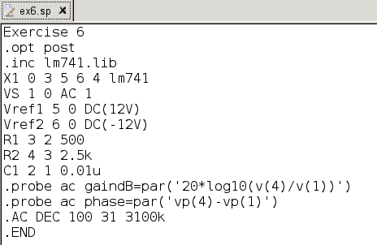

First Order High-Pass Filter Netlist

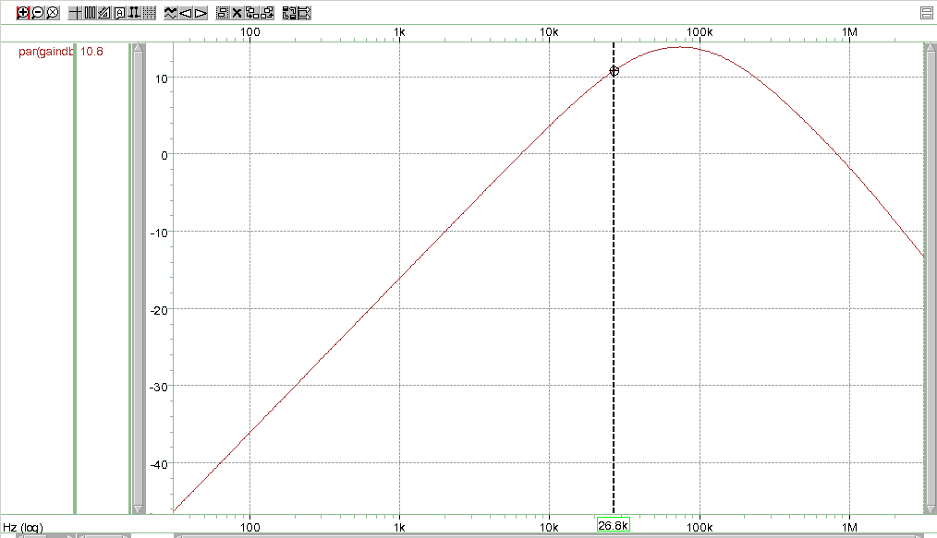

SPICE Simulation of First Order High-Pass Filter Gain (dB) versus Frequency (Hz)

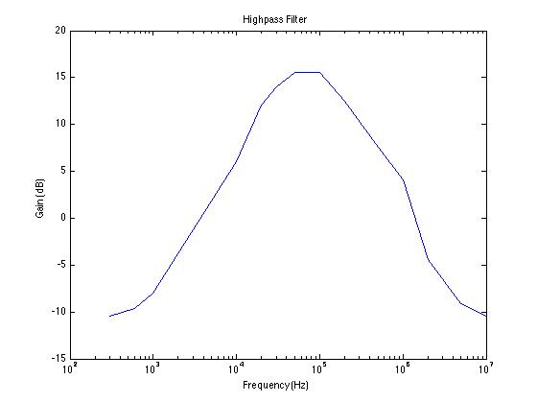

Measured Values of First Order High-Pass Filter Gain (dB) versus Frequency (Hz)

**Questions**

The pass band gain is 5 and the -3 dB frequency is 28,937 Hz in the circuit. The -3 dB frequency is slightly different than the theoretical value from the hand calculations because the value used for the capacitor was 11 nF instead of 10 nF, but the resistor values remained the same. As expected, the results derived in the pre-laboratory section agree with the results from the laboratory. The measured values compare to the calculated results by giving similar numbers, 28.9 kHz (measured value) and 26.8 kHz (SPICE simulation value), and similar plots of the response of the circuit with the change in frequency were obtained. In addition, the SPICE simulation had 13.8 dB gain when frequency was equal to zero, but in the case of the measured values the gain is equal to 15 dB.

**Discussion**

The results form the HSpice simulation match with the hand calculations. Therefore, the hand calculations were done correctly. The High-Pass Filter, does not actually work as a High-Pass Filter when using the LM741. That is due to its limitations and holes. As a result, the LM741 acts as a Band Pass Filter instead. Some of the subtle differences in the results are due to the fact that the LM741 used is not ideal, as opposed to the one used in the SPICE simulation. This is due to the fabrication process of the LM741 where we could possible find impurities or holes in the materials used to produce it.

**Conclusion**

The results clearly agree with the objective of the lab that is to learn how operational amplifiers function and how comparators and filters are built. In addition, we use HSpice and WaveView Analyzer to corroborate our hand calculations and our measured values. There is a significant amount of real life applications of this knowledge, so it is important to learn it in a class environment.